Smarch 13, 2013
Andrew Yakimovich, Director
Facility Planning & Design Services
1000 Chastain Road, MD#3602
Kennesaw, GA 30144-5591

Mr. Yakimovich:
I, on behalf of myself and my team members Jean-Paul Gaster, Dan Maines, and Tim Sult, offer a project to encourage KSU student health, promote community and entice new students. Enclosed is a proposal to research everything you would need to create a KSU on-campus dog park, from location and budget to layout and construction.
We believe that a dog park would enrich the student experience by encouraging healthy outdoor exercise with the added benefit of creating a social environment that brings students with similar interests together. Such a park can even be its own event location, further adding to Kennesaw State University’s desirability and sense of community. We believe that our status as KSU students offers us a personal, up-close perspective and can yield the best possible research for your department.
This proposal presents a detailed, fleshed-out plan to analyze the needs and desires of the community and to then use that data to create a park that is a perfect fit for Kennesaw State University. We will provide not only information to build the dog park, but maintenance options as well. We are confident that this proposal offers many benefits to our wonderful university.
Thank you for considering this project. We anticipate hearing your thoughts and are hopeful that we will have the pleasure to work with your department in the future. I am available by phone or email via the information listed below.
Sincerely,

Neil Fallon
nfallon@students.kennesaw.edu
404-555-1973
/jg

Enclosures: KSU Dog Park Proposal
Kennesaw State University On-Campus Dog Park Proposal
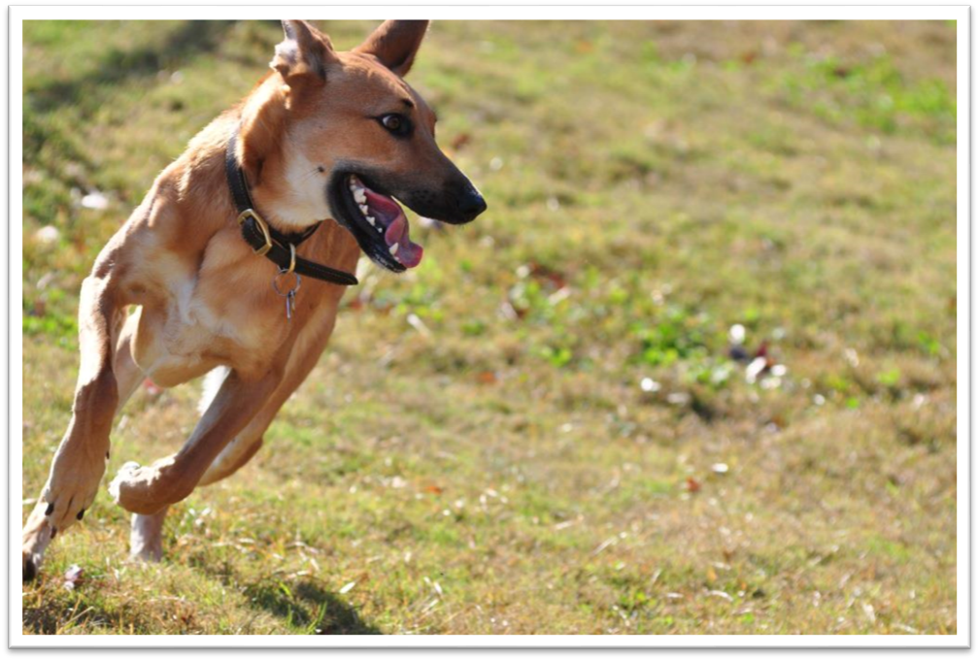
KSU Dog Park

Prepared By:
Neil Fallon
Jean-Paul Gaster
Dan Maines
Tim Sult
Prepared For:
Andrew Yakimovich, Kennesaw State University Director of Facility Planning and Design Services

Prepared Date: Smarch 13, 2013

Executive Summary

Smarch 13, 2013
This proposal offers an analysis of the community benefits of a dog park on KSU campus, as well as possible implementations of this plan. A dog park could provide a beneficial service to KSU students and guests while also providing a greater, more personal sense of community. Methods of research include investigating the dog population in the surrounding area, surveying locals and KSU students for community interest, examining potential locations, and estimating the startup and maintenance costs of the project. If approved, the report will include complete recommendations for the location and layout of the park, as well as funding options.
Provided in this proposal is a detailed schedule that outlines how we intend to execute this project. Spanning six months, this plan includes finding a location, surveying the area, researching park design and regulations, determining funding and budget, and, in the final steps, compiling the data into a report.
We feel that our qualifications make us the right people to execute this plan. Every team member is a KSU student and dog owner who is committed to our community. We can offer a uniquely informed perspective as we are the target demographic of this plan, and we can more easily get feedback from the community. One of our team members has many years of experience working with dogs in a canine day care, and he brings his personal knowledge of animal enrichment and health to the project.
The required budget to complete this work is $150 per hour, 20 hours a week per person, for six months, for a total of $234,000.00. We will provide you with a thoroughly researched recommendation that includes all the information you need to benefit the community and entice students to Kennesaw State University.

Table of Contents
Introduction 1
Proposed Program 2
Project Description 2
Approach/Research 3
Detailed Schedule 5
Qualifications 6
Budget 6
Conclusion 7
Bibliography 8

Introduction
‘‘If your dog is fat, you’re not getting enough exercise.’’ (Author unknown)
Many medical and psychological studies continue to investigate the correlation between dog ownership and health benefits. According to some studies, “pet owners report a reduction in minor health problems following pet acquisition and this effect is sustained over time in dog owners” (Arhant-Sudhir 734).
The health benefits of dog ownership include weight loss or maintenance, cardiovascular benefits such as reduced blood pressure, and reduced stress levels. (See Fig 1.) According to the information compiled by Arhant-Sudhir, et al, “a study in college students ¹²examining the effect of a pet on psychological consequences of stress indicated that, for some individuals, interacting with a pet favourably affects both physiological and psychological responses; the beneficial effect was similar to that seen by reading quietly “(735).
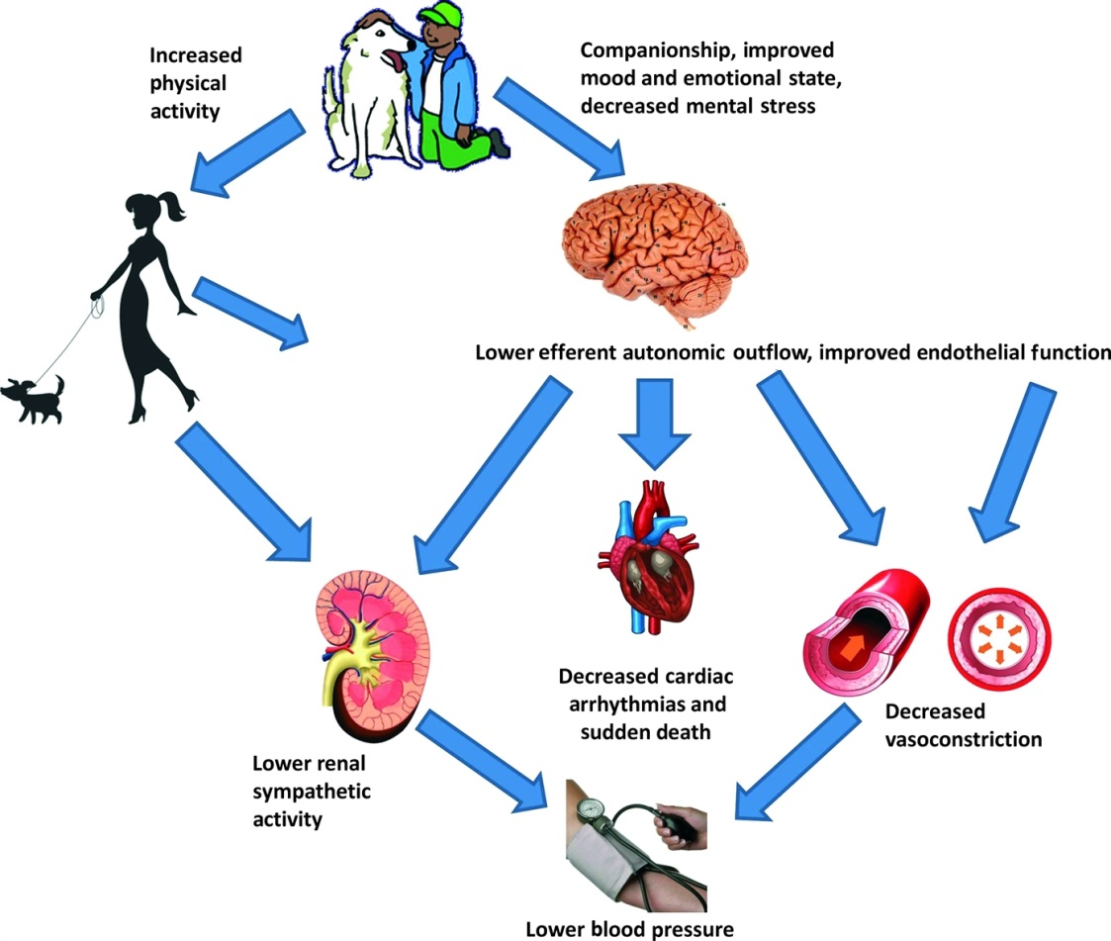
Fig 1. – Illustration of cardiovascular benefits of dog ownership (Arhant-Sudhir).

Benefits of dog parks are not limited to only the humans. “Off-leash dog parks provide safe and effective places where dogs can exercise, play, and interact with other dogs to reduce boredom and pent-up energy” (Lee 314). Play time, while fun for the animal and the human, actually fulfills an important part of a dog’s growth since “proper play helps to develop your dog’s coordination, timing and the skills needed for hunting and self-defense” (Allen 108). The play also makes dogs happier, reducing their alone time and inactivity. “Dogs are active. If you give them an outlet, they will burn off the excess energy running and playing… Pent-up energy makes anxiety and stress problems worse” (Allen 111).
There’s no info other than a page number in the header, and there’s no info in the footer, either. Always provide the reader with some navigation/identification material in case s/he has to put down the document and reorient her-/himself upon return.
Another important dog benefit is socialization. “Dogs that are well-socialized are happy, secure, confident dogs who are healthier because of a general reduction in stress. A well- socialized dog will readily interact with all types of people and will easily play with other dogs, as well” (HSSCV 1).
According to the Lee study:
Most respondents (71.0%) “strongly” agreed that dog parks help promote the physical health of their dogs. Over 64% of the respondents expressed the view that it is important for communities to include a dog park…and three-quarters of respondents consider a dog park as one of the important community amenities (320).
It is our proposal that the campus of KSU can sustain a dog park area to benefit both students and the general community, increasing the appeal of the KSU campus lifestyle, reducing stress among KSU students who are no longer forced to seek off-campus or non-local alternatives for exercising their animal companions, as well as promoting the general welfare of the student body by allowing dog owners a place to socialize with their animals without unreasonable safety fears.

Proposed Program

Project Description
Kennesaw State University is a large part of the city of Kennesaw and much of the city revolves around the university. There are roughly 30,000 citizens in the city and over 26,000 students enrolled at Kennesaw State. Among these people, we can assume that many are dog owners. Since Kennesaw State University is a centralized location, we believe that a dog park built on campus would be a beneficial addition to the community.
The addition of a dog park on the campus of KSU would provide a nearby park for citizens and students to exercise and play with their dogs. Many students live in apartments that allow animals but do not provide an area for dogs to be walked or exercised. This means students are either giving up their dogs, having dogs that do not receive the proper amount of exercise, or having to travel long distances to properly exercise their animals.
Exercise is vital to the life of a happy and healthy animal. A dog needs to be exercised daily to maintain a healthy weight and happy demeanor. A dog that is not exercised daily is more likely to have health issues such as weight problems, heart problems, diabetes, and joint issues. Also, dogs who do not receive adequate amounts of exercise are more likely to exhibit temperament problems due to excessive amounts of built-up energy. Thus, our addition of a dog park will be beneficial to our community by assisting in minimizing problematic dogs.

Approach/Research
We intend to research how to approach the construction of a dog park on Kennesaw State’s campus. Though we may discover more necessary research, we will conduct our primary research through surveys described below.
We will first investigate the community’s interest in the park. We will begin with dog owners in the area. We anticipate obtaining customer lists from veterinarians, doggy daycares, pet stores, as well as registered pet owners within apartment complexes. This will provide an idea of how many homes have dogs in the area.
We will then proceed with primary research by surveying students and citizens with dogs or who would like to have dogs to ascertain their needs and interest in having a local dog park. We will conduct usage surveys as listed below:
    - KSU students and prospective students
      - How many students currently residing near campus would benefit from an on-campus dog park?
      - Will an on-campus dog park affect their decision to remain closer to campus after graduation?
      - Will an on-campus dog park affect their enrollment decision?
      - How many hours per week would they estimate using the dog park?
    - Local residents
      - To which dog park do you currently take your animal companion?
      - Would a publicly-accessible dog park within the KSU campus reduce the amount of time you spend driving to a dog park now?
We will also investigate already-established dog parks and dog-oriented groups that are local to the Kennesaw State area. We will conduct these reviews as follows:
    - Evaluate existing facilities
      - What dog parks are currently available within Cobb County? The City of Marietta?
      - What types of amenities are available at these parks?
      - What do on-line commentators or reviews post regarding these parks?
    - Evaluate existing programs
      - What is the success rate for the KSU Wellness Center’s “Paws and Relax” program when it is held during exam week?
We will then continue by having a petition signed by interested parties in order to support the construction of the park.
We will also research a location for the park on campus. The location for the park will need to be a grassy area that is not too close to any major roads. This is essential to ensure that any dogs that may escape from their owners do not run into any roads with heavy traffic. We want to provide a feeling of safety to both dogs and their owners at our park. The park should not be too close to any living quarters as a dog park usually contains many happy, barking dogs. We do not want our park to be a nuisance or bother to the community in any way.
Once our location is selected, we will survey the area for a minimum of six months in order to research what, if any, usage of the current area is occurring. We will also be able to monitor the physical condition of the park for two seasons in order to give us an idea of necessary future maintenance (City of Atlanta 2).
We will also explore the cost of the project. This project will require some funding to begin but we anticipate that it will require little funding to be maintained for the future. We will research the initial cost which will include the cost of purchasing the property, the cost for the fencing, the cost for the installation of fencing and the cost to provide commodities such as a drinking fountain, dog bags, and waste disposal.
If research for our project is approved, our team will contact landscape architects in order to provide you a layout of the park that is drawn to scale and includes details such as the structure (i.e. separate yards for large and small dogs), safety features, signage with regulations, utilities, and amenities.
For long-term maintenance of the project, we will delve into several options. We will research the cost for the city to maintain the park, the cost if the school was to maintain the park or the possibility of outside maintenance. We will contact local animal groups and programs to look into the possibility of volunteers to maintain the dog park.
In order to complete our project, we will investigate possible long-term funding options. We will speak with the local apartment complexes primarily, as they may benefit from having a nearby area for residents to take their dogs. We will also speak with the school and with local animal programs for funding. We will also research the possibility of donations from interested parties for the building of our park, such as corporate sponsors or volunteer groups.
Due to the fact that our park will remain for years to come, we feel it is important to acquire community support in order to maintain, manage, and monitor the park. We will reach out to the community by researching and contacting local dog shelters, non-profit rescues, non-profit animal support groups, and dog meet-up groups. These groups provide valuable support networks for dog owners, as well as potential organizations through which fund raising options should be explored.
Our team will provide a report after our research which will include a budget with total project cost, a layout of the park, the best location for the park, how to maintain the park, and funding options for the park.

Detailed Schedule
The previously detailed research may begin almost immediately upon this proposal’s acceptance. Once approved, this project will culminate in a formal report six months later. This time will be spent accumulating information on community interest and the logistics of constructing a dog park. See Fig. 2 for a general overview of events.
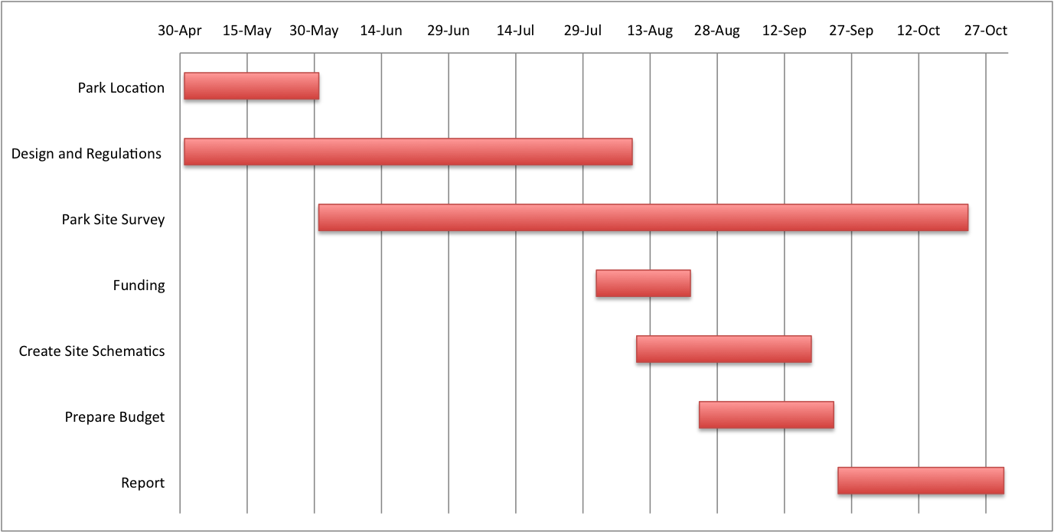
Fig. 2 – Detailed Scheduled of Research
We can begin our research immediately, beginning on May 1. The steps in the plan are broken down as follows:
- Park Location: We will begin looking for the ideal placement for the park. Included in this research is gathering information about local dog owners and their desires for the park.
- Design and Regulations: We will be researching proper dog park design and various government regulations as we find a location for the park.
- Park Site Survey: Once we have found the best possible location we will begin surveying that area to determine the needs specific to that area.
- Funding: We will explore options for receiving funding from outside sources
- Create Site Schematics: At this point we will begin drawing up blueprints and planning construction.
- Prepare Budget: We will create a budget including building materials and work costs.
- Report: We will compile our research in a report that will be delivered on Nov 1.

Qualifications
As a team of devoted dog owners and lovers, we have a personal interest in the construction of this dog park. We are, in fact, all students of Kennesaw State University and residents of the city of Kennesaw. We would personally benefit from the creation of the park and we feel that every other dog owner in the area would benefit as well.
One of our team members, Tim Sult, has worked with dogs for years and has been trained on the importance of exercise for pets, for both their mental and physical health. Our team member is a level one pet care technician and is also trained in pet CPR and first aid. Tim spent many years working in a doggy daycare where dogs played in yards very similar to that of a dog park. He experienced first-hand the positive impact that a doggy daycare has on members of the daycare. However, not every citizen is able to afford such a luxury. A dog park offers the same exercise and positive impact but is a resource available to the entire community.
With our knowledge and personal interest, we believe that we will be able to provide you the best and most accurate information regarding the construction of an on campus dog park.

Budget
To research the proposed KSU Dog Park, our team has allotted the following budget items:
- Conducting usage surveys
  - KSU Students
  - Local Residents
- Performing reviews
  - Evaluate Existing facilities
    - Closest dog park to KSU
  - Evaluate success of KSU’s “Paws and Relax” program
- Evaluating landscape architects
  - Creating a dog park will require a professional landscape architect firm to provide the following services
    - Land preparation (surveying, grading)
    - Fencing
    - Piping
    - Planting
- Identifying fund raising opportunities for sustainability
  - Local Organization and Community Outreach
  - Municipal involvement
  - Corporate sponsors
- Preparing a final report
  - Include recommendations for:
    - Park location and layout
    - Park amenities and features as identified by survey and reviews
    - Contract information for landscape architects
    - Fund raising viability or any financial off-set
Total time: 6 months
Our Required Budget for Research
- Payment
  - Rate – 150.00 per hour
  - 20 hrs per week, per person = 60 hrs per week on project

The final cost for the research proposed would total $234 000.00.

Conclusion
There are many medical benefits to owning a dog, but ownership also comes with responsibility to ensure the dog is well-cared for, including exercise and socialization. It is our belief that installation of a dog park within the Kennesaw State University campus would provide not only students but also the community at-large a resource for both human and canine health benefits. KSU offering an amenity such as an on-campus dog park would offer students and residents living near campus an opportunity to care for their animal companion, as well as themselves.
We believe our research will indicate not only a need but a strong desire for a dog park within the Kennesaw State University campus. Once this has been established, our team will be able to furnish a compiled report including the recommended location, size, a reputable landscape architect firm for installation of the park, as well as funding options to sustain the park. With this information, Kennesaw State University can add a feature that will benefit both students and the community for years to come, further adding to the KSU legacy.

Bibliography
Allen, Laurel. “Dog Parks: Benefits and Liabilities”. University of Pennsylvania Scholarly Commons. 29 May 2007. Web. 15 Apr. 2013
Arhant-Sudhir, Kanish, Rish Arhant-Sudhir, and Krishnankutty Sudhir. "Pet Ownership And Cardiovascular Risk Reduction: Supporting Evidence, Conflicting Data And Underlying Mechanisms." Clinical And Experimental Pharmacology & Physiology 38.11 (2011): 734-738. MEDLINE with Full Text. Web. 15 Apr. 2013.
City of Atlanta. Department of Parks, Recreation and Cultural Affairs, 2010. Web. 14 April 2013.
Humane Society of Santa Clara Valley (HSSCV). “Socialization: The Key to a Confident Dog” Web. 16 April 2013.
Lee, Hyung-Sook, Shepley Mardelle, and Huang Chang-Shan. "Evaluation Of Off-Leash Dog Parks In Texas And Florida: A Study Of Use Patterns, User Satisfaction, And Perception." Landscape And Urban Planning 92.(n.d.): 314-324. ScienceDirect. Web. 16 Apr. 2013.

For the most part, you did very well on this proposal. You made a clear, internally consistent, and understandable request to be hired as consultants; clearly described the project you envision; organized the contents in a logical order (except as noted in comment #4); and created a generally well-designed and almost error-free document.
As noted above, however, two important problems weren’t addressed: the presence of Swift-Cantrell Park and the distinct possibility that there’s no suitable on-campus location. You’ll have to consider these factors in your report.
If your group worked for a consulting company and I was your supervisor, I’d be very pleased with this proposal. I’d ask for revisions based on the two problems noted above and a few other revisions based on my comments above, but I wouldn’t ask for significant fixes.
According to the grading criteria posted on the course website, this proposal must receive a B-plus.
A – | The A grade represents superiority in composition, content, and style. An A paper exceeds all the objectives of the assignment. The contents are original, ethical, sophisticated, thorough, and ideally suited for the audience. The style is clear and appropriate to the subject, purpose, and audience. The organization and design of the document make the information understandable, accessible, and usable. The mechanics and grammar are excellent. As rhetoric, an A paper convinces the reader of the soundness and validity of its argument. The true A paper, relatively rare, goes way beyond expectations.
B – | The B grade indicates above-average work. A B paper meets the objectives of the assignment, but it requires minor improvements or reveals easily correctable errors in organization, style, design, grammar, or mechanics. As rhetoric, a B paper makes a sound argument, but lacks the brilliance of an A paper.
C – | The C grade represents work of average quality: it is the grade that most papers receive. A C paper presents and illustrates a clearly stated thesis and avoids serious errors; it lacks, however, the rigor of thought, development, and expression required for a grade of A or B. A paper receiving a grade of C or higher must have few mechanical errors. On the other hand, an essay may denote the writer's competence in grammar, punctuation, mechanics, and diction and still receive a grade of below C because the organization or content is unsatisfactory. As rhetoric, a C paper is an argument with perhaps some strong features, but with some problems.
D – | The D grade represents a disappointing document. A D paper meets some of the objectives of the assignment but ignores others; the discussion is inadequately developed, omits important information, or displays numerous or major errors in organization, style, design, grammar, or mechanics. For example, a paper with errors in subject-verb agreement, comma splices or fused sentences, sentence fragments, illogical sentences, or numerous spelling errors should not be awarded a grade higher than a D. As rhetoric, the D paper has little to commend its argument.
F – | The F grade designates writing that is unacceptable at the university level. An F paper omits critical information, does something other than the assignment required, or displays major or excessive errors in organization, style, design, grammar, or mechanics. As rhetoric, the F paper fails to persuade.

